**REGISTERATION FOR ROYAL CHALLENGERS BENGALURU PLAYER FORM**

**A PROJECT REPORT**

***Submitted by***

**JEGATHEESH A (23UIT074)**

**SRIPRIYADHARSHANT(23UIT098)**

**SACHIN A (23UIT110)**

***in partial fulfillment for the award of the degree of***

**BACHELOR OF TECHNOLOGY**

**IN**

**INFORMATION TECNOLOGY**



**DEPARTMENT OF INFORMATION TECHNOLOGY KAMARAJ COLLEGE OF ENGINEERING AND TECHNOLOGY**

**(An Autonomous Institution - Affiliated to Anna University, Chennai) K.VELLAKULAM, VIRUDHUNAGAR - 625 701**

**MAY 2025**

**KAMARAJ COLLEGE OF ENGINEERING AND TECHNOLOGY**

**(An Autonomous Institution- Affiliated to Anna University, Chennai)**

**K.VELLAKULAM, VIRUDHUNAGAR – 625 601**

**BONAFIDE CERTIFICATE**

Certified that the project report “**REGISTERATION FOR ROYAL CHALLENGERS BENGALURU FORM”** is the bonafide work **of “JEGATHEESH A (23UIT074) & SRI PRIYADHARSHAN T (23UIT098) & SACHIN A (23UIT110)”** who carried out the project work under my supervision.

**SIGNATURE SIGNATURE**

**Dr. E. VAKAIMALAR Mrs. S. GAYATHRI**

**Head of the Department, SUPERVISOR,**

Associate Professor, Assistant Professor,

Dept. of Information Technology, Dept. of Information Technology Kamaraj College of Engg & Tech, Kamaraj College of Engg &Tech, K.Vellakulam, K.Vellakulam,

Virudhunagar - 625 701. Virudhunagar - 625701.

**INTERNAL EXAMINER EXTERNAL EXAMINER**

**ABSTRACT:**

This registration initiative for Royal Challengers Bangalore (RCB) invites passionate cricket fans and aspiring players to connect with one of the most electrifying teams in the Indian Premier League. Through this platform, individuals can register for exclusive events, fan clubs, talent hunts, merchandise updates, and other interactive RCB community activities. Whether you're a die-hard supporter or an emerging cricketer with dreams of greatness, this registration is your chance to join the RCB family and share the pride of “Ee Sala Cup Namde!”Get ready to roar with the power of the Challengers! The Royal Challengers Bangalore registration drive is your ticket to officially becoming a part of the RCB legacy. Whether you're a loyal fan, a cricket enthusiast, or someone who thrives on the electric atmosphere of red and gold, this is your moment to rise and be part of the team that makes every match day unforgettable. RCB isn’t just a team—it’s a spirit, a movement, and now, your home.This registration unlocks a world of exclusive experiences—fan events, match-day activities, official merchandise, early ticket access, and much more. It’s not just about signing up; it’s about becoming a member of a community that celebrates cricket with unwavering passion and pride.

**ACKNOWLEDGEMENT:**

I would like to express my deepest gratitude to everyone who contributed to the successful completion of this Registeration for Royal Challengers Bengaluru . First and foremost, I am thankful to my mentor Mrs. S.Gayathri, AP/IT, for her invaluable guidance, feedback, and encouragement throughout the development process. Her expertise and insights greatly shaped the direction of this project.

I would also like to extend my appreciation to my colleagues and peers, whose collaborative efforts and support were instrumental in addressing challenges and finding solutions during the project.

Finally, I am grateful to my family and friends for their constant encouragement and understanding, which motivated me to keep pushing forward. This project would not have been possible without the collective support of all those involved, and I am sincerely thankful to each one of you.

|  |  |  |
| --- | --- | --- |
|  | **TABLE OF CONTENTS** |  |
| **CHAPTER NO.** | **TITLE** | **PAGE NO.** |
|  | **ABSTRACT** | **iii** |
|  | **LIST OF FIGURES** | **vi** |
| **1.** | **INTRODUCTION** | **1** |
|  | 1.1 HTML | 1 |
|  | 1.2 CSS | 1 |
|  | 1.3 JavaScript | 1 |
| **2.** | **METHODOLOGY** | **2** |
|  | 2.1 Objective | 2 |
|  | 2.2 Problem Statement  2.3 code explanation  2.4 Explanation | 2  3  8 |
| **3.** | **RESULTS AND DISCUSSION** | **12** |
| **4.** | **CONCLUSION** | **13** |
| **5.** | **REFERENCES** | **14** |

**LIST OF FIGURES**

|  |  |  |
| --- | --- | --- |
| **FIGURE NO.** | **TITLE** | **PAGE NO.** |
| 2.4.1.1 | Home page for Royal Challengers Bengaluru | 10 |
| 2.4.2.2 | VIRAT for Royal Challengers Bengaluru | 26 |
| 2.4.2.3 | Registration page for Royal Challengers Bengaluru | 26 |
| 2.4.2.4 | Completely Registration page for Royal Challengers  Bengaluru | 27 |
| 2.4.2.5 | About page for Royal Challengers Bengaluru | 27 |
| 2.4.2.6 | Virat Kohli Key Historical Moments | 28 |

**CHAPTER 1 INTRODUCTION**

**1.1. HTML:**

HTML is the standard language used to create and structure content on the web. It provides the foundational structure for web pages, using a series of elements or tags to define text, images, links, and other multimedia. HTML defines how the content will be displayed in the browser, making it essential for creating the skeleton of any website. It works in conjunction with CSS and JavaScript to bring interactivity and styling to web pages.

* **CSS:**

CSS is the language used to describe the presentation and layout of a web page. While HTML defines the structure, CSS is responsible for the visual appearance, including colors, fonts, spacing, and positioning of elements. CSS allows developers to separate content from design, providing flexibility in how web pages are styled and enabling responsive design, ensuring that web pages look good on all devices, from desktops to smartphones.

* **JAVASCRIPT:**

JavaScript is a dynamic programming language that adds interactivity and functionality to web pages. It allows developers to create interactive elements such as form validation, animations, and event handling. JavaScript can manipulate the HTML and CSS of a web page, enabling real-time updates and dynamic content changes. It plays a crucial role in building user interfaces.

**CHAPTER 2 METHODOLOGY**

* **OBJECTIVE:**

The primary objective of the Royal Challengers Bangalore (RCB) registration is to establish a dynamic and interactive platform where fans, cricket enthusiasts, and aspiring players can connect directly with the RCB franchise. This initiative seeks to strengthen the bond between the team and its dedicated supporters by providing exclusive access to fan events, merchandise, match updates, and various engagement opportunities. Furthermore, it offers a structured system to identify, appreciate, and reward individuals who contribute to the thriving RCB community. Through this registration, we aim to cultivate an inclusive, passionate, and energetic fan base that proudly represents the spirit of “Ee Sala Cup Namde” and carries it forward across the globe.

* **PROBLEM STATEMENT:**

Despite having one of the most passionate and expansive fan bases in the cricketing world, Royal Challengers Bangalore (RCB) faces challenges in maintaining a centralized and efficient platform for engaging with its supporters. Many fans often miss out on timely updates, official events, merchandise releases, and exclusive experiences due to fragmented communication channels and disorganized registration processes. Furthermore, the absence of a unified system makes it difficult to effectively identify and connect with devoted fans and budding cricketing talents. Consequently, there is a critical need for a structured registration platform that not only bridges the gap between the RCB franchise and its supporters but also amplifies fan engagement, loyalty, and participation in all RCB-related activities.

CODE EXPLANATION:

Folder name: REGISTERATION FOR ROYAL CHALLENGRS BENGALURU ,

**2.3.1.home.html**

<!DOCTYPE html>

<html>

<head>

<title> Home </title>

<link rel="stylesheet" href="style.css">

</head>

<body>

<center>

<div class="logo"><img src="rcb.jpg" alt="rcb logo"></div>

</center>

<nav>

<a href="index.html">Home</a>

<a href="virat.html">Register</a>

<a href="about.html">About</a>

<!-- <a href="contact.html">Contact</a>

<a href="gallery.html">Gallery</a> -->

</nav>

<h1>Welcome to cricket World</h1>

<div class="container">

<p> "Royal Challengers Bengaluru is not just a team—it's an emotion." </p>

<br>

<p> >Royal Challengers Bengaluru, formerly known as Royal Challengers Bangalore, commonly known as RCB, is a professional franchise cricket team based in Bengaluru, Karnataka, competing in the Indian Premier League. Founded in 2008 by United Spirits, currently managed by Prathamesh Mishra, the team is named after the liquor brand, Royal Challenge. The M. Chinnaswamy Stadium in Bengaluru is their home ground. It is the most popular and followed cricket franchise with more than 18 million followers on Instagram.

As of 2025, the team is captained by Rajat Patidar and coached by Andy Flower. Royal Challengers have finished as runners-up on three occasions, in 2009, 2011, and 2016, and have qualified for the playoffs in nine seasons. The franchise has competed in the Champions League, finishing as runners-up in the 2011 season. As of 2024, RCB was valued at $117 million, making them one of the most valuable IPL franchises.

</p>

<br>

<h1> HISTROY </h1>

<p>2008–2010: Initial seasons

Main articles: Royal Challengers Bangalore in 2008, 2009, and 2010

In September 2007, the Board of Control for Cricket in India (BCCI) announced the establishment of the Indian Premier League (IPL), a Twenty20 competition set to begin in 2008. On 24 January 2008, an auction was held in Mumbai for the league's teams, which represented eight different cities in India, including Bengaluru. The Bangalore franchise was acquired by Vijay Mallya for US$111.6 million, making it the second-highest bid, slightly less than Reliance Industries' US$111.9 million bid for the Mumbai Indians.

Rahul Dravid was the team's icon player in 2008.

Ahead of the 2008 player auction, the IPL designated Rahul Dravid as the icon player for the Bangalore franchise. This designation ensured that Dravid would be paid 15% more than the highest bid player at the auction. The franchise acquired several prominent Indian and international players, including Jacques Kallis, Anil Kumble, Zaheer Khan, Mark Boucher, Dale Steyn, and Cameron White. In the second round of the auction, they also signed Ross Taylor, Misbah-ul-Haq, and India under-19 World Cup-winning captain Virat Kohli. The franchise named Dravid as the captain of the team and appointed Venkatesh Prasad as the head coach. The team struggled in the inaugural season, winning only four out of their 14 matches and finishing seventh in the eight-team table. Dravid was the sole player to score more than 300 runs in the tournament, and the team even had to bench their most expensive foreign player, Kallis, for several matches due to his poor form. Midway through the season, the string of failures led to the sacking of CEO Charu Sharma, who was replaced by Brijesh Patel. Mallya publicly criticised Dravid and Sharma for their selection of players at the auction, stating that his "biggest mistake was to abstain from the selection of the team." Eventually, the chief cricketing officer of the franchise, Martin Crowe, resigned and Prasad was replaced by Ray Jennings as the head coach </p>

</div>

</body>

</html>

**2.3.2.STYLECSS**

body {

font-family: Arial, sans-serif;

margin: 0;

background-color: #f5f5f5;

}

body {

background-image: url("rcc.jpg");

background-repeat: no-repeat;

background-attachment: fixed;

background-size: cover;

}

nav {

background-color: #000;

padding: 10px 20px;

text-align: center;

}

nav a {

color: white;

text-decoration: none;

margin: 0 15px;

font-weight: bold;

}

h1 {

text-align: center;

margin-top: 30px;

}

.container {

padding: 20px;

text-align: center;

}

.toy {

display: inline-block;

background-color: white;

margin: 15px;

padding: 15px;

border-radius: 10px;

width: 220px;

box-shadow: 0 4px 8px rgba(0,0,0,0.1);

}

.toy img {

width: 100%;

height: auto;

border-radius: 8px;

}

button {

background-color: #25D366;

color: white;

border: none;

padding: 10px;

border-radius: 5px;

cursor: pointer;

margin-top: 10px;

}

button:hover {

background-color: #128C7E;

}

/* Animations and logo styling */

.logo {

text-align: center;

padding: 15px;

animation: fadeInDown 1s ease-out;

}

.logo img {

width: 200px;

}

@keyframes fadeInDown {

from {

opacity: 0;

transform: translateY(-20px);

}

to {

opacity: 1;

transform: translateY(0);

}

}

.toy:hover {

transform: scale(1.05);

transition: transform 0.3s ease;

}

**2.3.3.Register.html**

<!DOCTYPE html>

<html lang="en">

<head>

<meta charset="UTF-8" />

<meta name="viewport" content="width=device-width, initial-scale=1.0"/>

<title>Virat Kohli in RCB</title>

</head>

<body>

<div class="tab">

<button onclick="navigateTo('home')">Home</button>

<button class="active-btn" onclick="openTab('virat', this)">Virat Kohli in RCB</button>

<button onclick="openTab('register', this)">Register for RCB Team</button>

<button onclick="navigateTo('about')">About</button>

</div>

<div id="virat" class="tabcontent active-tab">

<h1>Virat Kohli - The Icon of Royal Challengers Bangalore</h1>

<div class="player-images">

<img src="vi.jpg" alt="Virat Kohli Batting">

<img src="vir.jpg" alt="Virat Kohli RCB">

<img src="vira.jpg" alt="Virat Kohli Iconic">

</div>

<section>

<p>

Virat Kohli, the face of Royal Challengers Bangalore (RCB), has been a central figure in the IPL ever since its inception. Known for his aggressive batting and leadership, Kohli is one of the most successful and beloved cricketers globally.

</p>

<p>

Under his captaincy, RCB reached multiple IPL finals, and his passion for the game is unparalleled. His performances both as a player and captain have made him one of the most respected players in modern cricket.

</p>

<p>

Despite not winning the IPL title yet, Kohli continues to inspire the team and fans with his commitment, passion, and unmatched energy on the field.

</p>

</section>

<section>

<h2>🏆 Career Highlights</h2>

<ul style="list-style: none; padding-left: 0; display: flex; flex-wrap: wrap; justify-content: center; gap: 20px;">

<li>🥇 2013 ICC Champions Trophy Winner</li>

<li>🏆 2016 IPL Finalist</li>

<li>🏆 2011 ODI World Cup Winner</li>

<li>🎯 70+ International Centuries</li>

<li>🏏 Fastest to 8000, 9000, 10000 ODI Runs</li>

</ul>

</section>

<section>

<h2>💬 Iconic Virat Kohli Quote</h2>

<blockquote>

"I don’t play to be average, I play to be the best." – Virat Kohli

</blockquote>

</section>

<section>

<h2>📌 Virat Facts</h2>

<ul style="max-width: 800px; margin: 0 auto;">

<li>🏏 Virat is known for his fitness regimen, often inspiring youth to stay fit.</li>

<li>📱 Virat has a massive social media following and is a brand ambassador for various companies.</li>

<li>🎮 He’s a big fan of gaming, especially football, and supports various sports beyond cricket.</li>

<li>🧘 Kohli practices yoga and meditation to stay mentally sharp and calm during high-pressure situations.</li>

<li>🍽️ Known for his healthy eating habits and often advocates for a balanced lifestyle.</li>

</ul>

</section>

<section>

<h2>📅 RCB Journey Timeline</h2>

<div style="display: flex; flex-direction: column; gap: 10px; max-width: 600px; margin: 0 auto; border-left: 3px solid #f1c40f; padding-left: 20px;">

<div><strong>2008:</strong> Joined RCB, a star from the beginning</div>

<div><strong>2011:</strong> RCB made it to the IPL final</div>

<div><strong>2013:</strong> Became RCB captain</div>

<div><strong>2016:</strong> Led RCB to another IPL final</div>

<div><strong>2024:</strong> Still leading and inspiring RCB with unmatched energy</div>

</div>

</section>

</div>

<div id="register" class="tabcontent">

<h2>Register to Join the RCB Dream</h2>

<form id="rcbForm" enctype="multipart/form-data">

<div class="form-group">

<label for="name">Full Name:</label>

<input type="text" id="name" name="name" required>

</div>

<div class="form-group">

<label for="age">Age:</label>

<input type="number" id="age" name="age" required>

</div>

<div class="form-group">

<label for="email">Email Address:</label>

<input type="email" id="email" name="email" required>

</div>

<div class="form-group">

<label for="phone">Phone Number:</label>

<input type="tel" id="phone" name="phone" pattern="[0-9]{10}" required>

</div>

<div class="form-group">

<label for="role">Playing Role:</label>

<select id="role" name="role" required>

<option value="">--Select--</option>

<option value="batsman">Batsman</option>

<option value="bowler">Bowler</option>

<option value="allrounder">All-Rounder</option>

<option value="wicketkeeper">Wicket Keeper</option>

</select>

</div>

<div class="form-group">

<label for="experience">Cricket Experience:</label>

<select id="experience" name="experience" required>

<option value="">--Select--</option>

<option value="beginner">Beginner (0–2 years)</option>

<option value="intermediate">Intermediate (2–5 years)</option>

<option value="advanced">Advanced (5+ years)</option>

</select>

</div>

<div class="form-group">

<label for="hand">Preferred Hand:</label>

<select id="hand" name="hand" required>

<option value="">--Select--</option>

<option value="right">Right-Handed</option>

<option value="left">Left-Handed</option>

<option value="ambidextrous">Ambidextrous</option>

</select>

</div>

<div class="form-group">

<label for="bio">Brief Bio / Achievements:</label>

<textarea id="bio" name="bio" rows="4" placeholder="Tell us about your cricket journey..." style="width: 100%; padding: 10px; border-radius: 8px;"></textarea>

</div>

<div class="form-group">

<label for="photo">Upload Your Photo:</label>

<input type="file" id="photo" name="photo" accept="image/*">

</div>

<button type="submit" class="submit-btn">Submit Registration</button>

</form>

</div>

<footer>

© 2025 Royal Challengers Bangalore Fan Page | Made with ❤️ for Kohli & RCB

</footer>

<script>

function openTab(tabName, btn) {

const contents = document.querySelectorAll('.tabcontent');

const buttons = document.querySelectorAll('.tab button');

contents.forEach(c => c.classList.remove('active-tab'));

buttons.forEach(b => b.classList.remove('active-btn'));

document.getElementById(tabName).classList.add('active-tab');

btn.classList.add('active-btn');

}

document.getElementById('rcbForm').addEventListener('submit', function(e) {

e.preventDefault();

alert('Thank you for registering with RCB! We’ll contact you soon.');

this.reset();

});

</script>

</body>

</html>

**2.3.4. About.html**

<!DOCTYPE html>

<html>

<head>

<title>Hot Wheels - About</title>

<link rel="stylesheet" href="style.css">

</head>

<body>

<center>

<div class="logo"><img src="rcb.jpg" alt="rcb Logo">

}

</div>

</center>

<nav>

<a href="index.html">Home</a>

<a href="virat.html">Register</a>

<a href="about.html">About</a>

<!-- <a href="contact.html">Contact</a>

<a href="gallery.html">Gallery</a> -->

</nav>

<h1>About Us</h1>

<div class="container">

<p><h3> Royal Challengers Bengaluru is an Indian professional T20 cricket franchise based in Bengaluru, Tamil Nadu. The team competes in the Indian Premier League (IPL) and was one of the eight franchises incorporated when the league was established in 2008. <h3></p>

</div>

</body>

</html>

**2.4 Explanation :**

**🟨 1. Document Declaration and HTML Start**

Defines the type of document and begins the HTML structure.

**🟨 2. Head Section**

Sets of the page and links the external CSS file for styling.

**🟨 3. Body Start and Logo**

Starts the visible part of the webpage and displays the RCB logo at the top.

**🟨 4. Navigation Bar**

Provides menu links to other pages like Home, Register, and About. Some links are commented out for future use.

**🟨 5. Welcome Heading**

Displays a bold heading to welcome users to the cricket-themed page.

**🟨 6. Main Content Container Start**

Starts a section to hold all main information neatly inside a styled container.

**🟨 7. RCB Tagline**

Shows a fan-favorite quote about RCB to add emotional value and engagement.

**🟨 8. About RCB Paragraph**

Describes the team’s background, achievements, stadium, leadership, and financial value.

**🟨 9. Section Heading – HISTORY**

Introduces the history section of the team.

**🟨 10. RCB Early History Paragraph**

Explaines early formation of the team, first matches, initial squad, performance in the first two seasons, and key achievements.

**🟨 11. Close Container and Page**

Ends the content container, the body, and the HTML document structure.

**Output :**

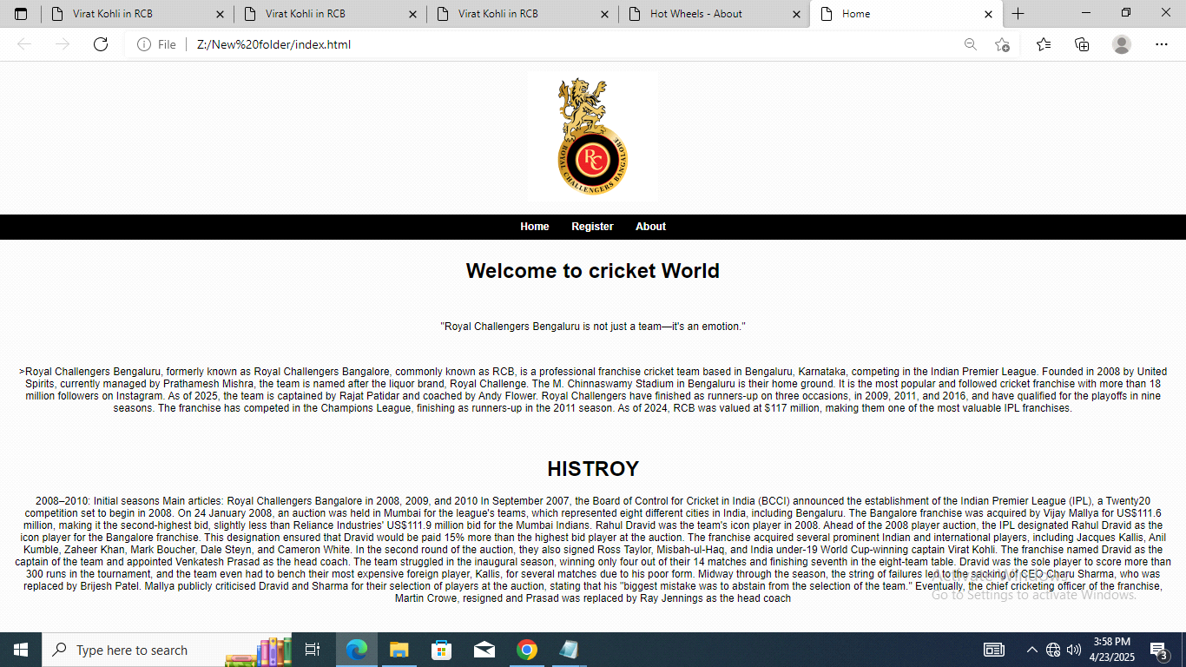

**Fig.2.5.1.Home page for Royal Challengers Bengaluru**

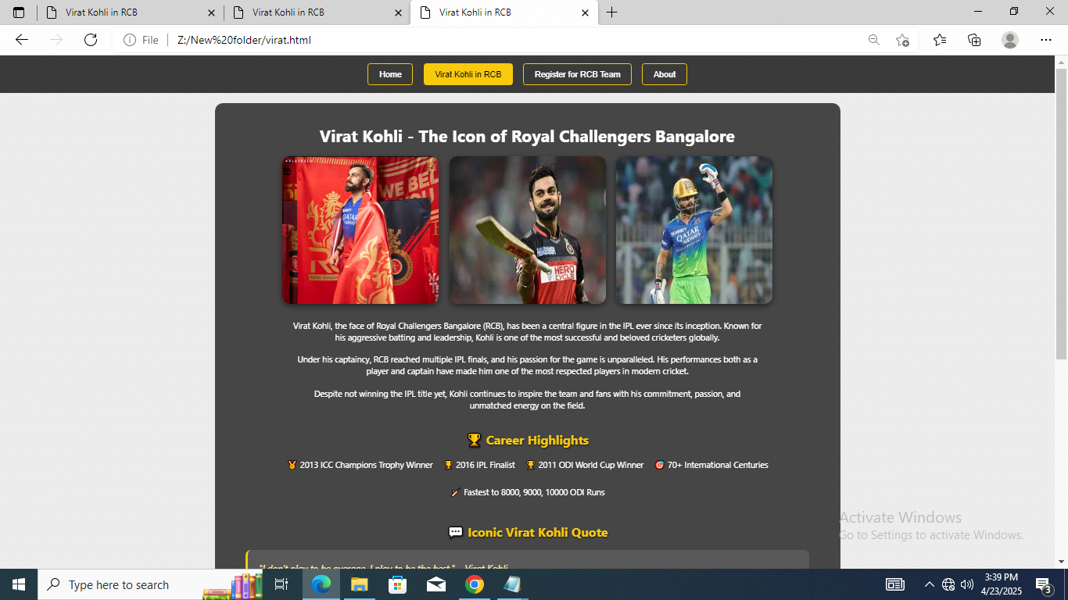

**Fig.2.5.2 .VIRAT for Royal Challengers Bengaluru.**

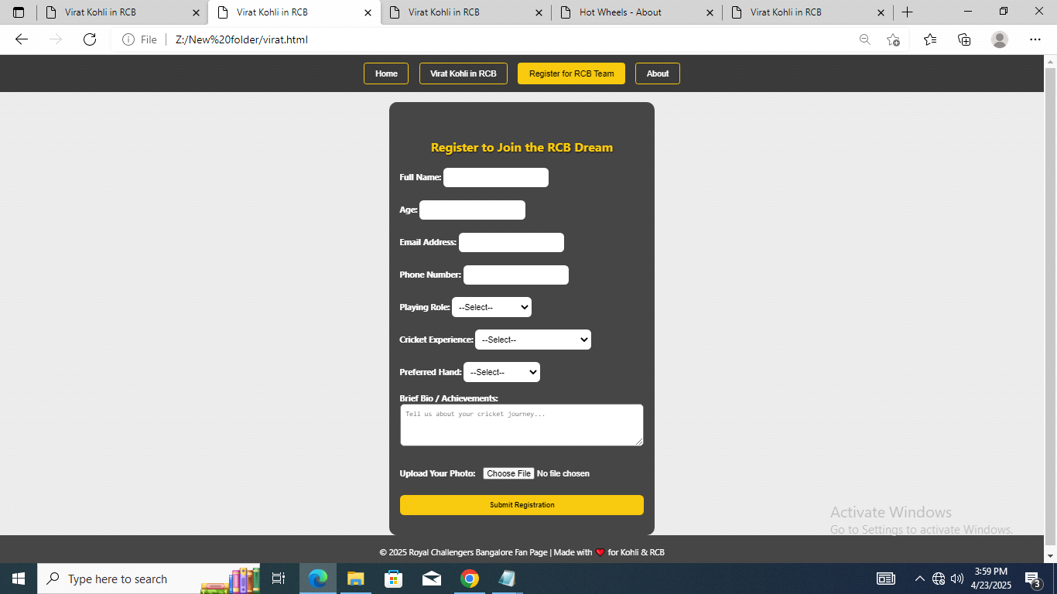

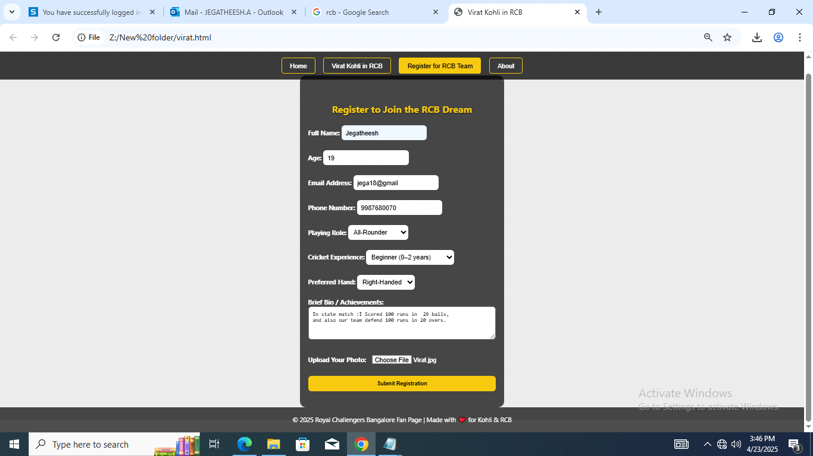

**Fig.2.5.3..Registeration page for Royal Challengers Bengaluru.**

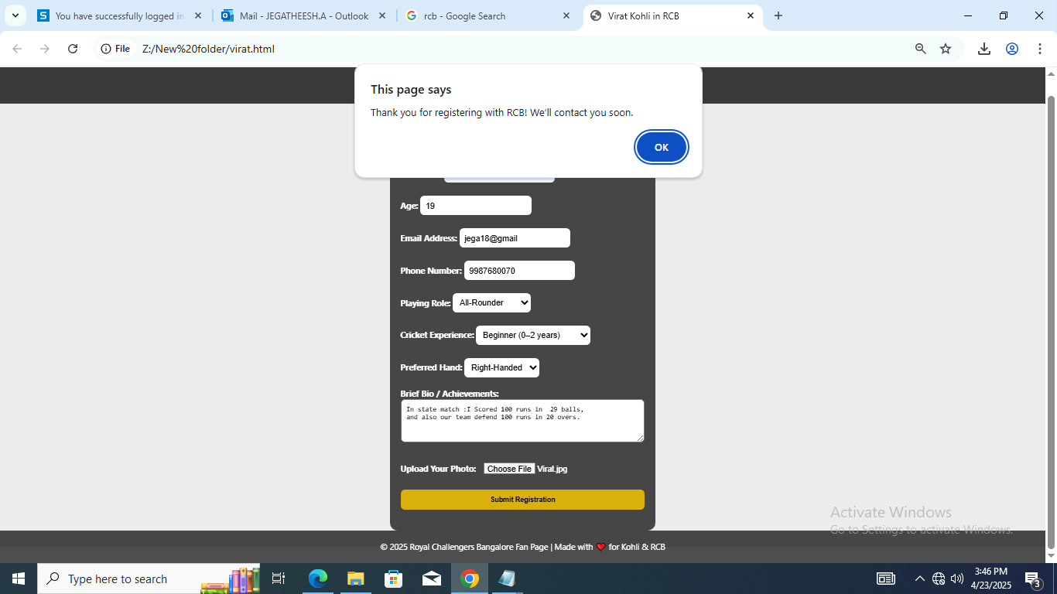

**Fig.2.5.4 Completely Registeration page for Royal Challengers Bengaluru.**

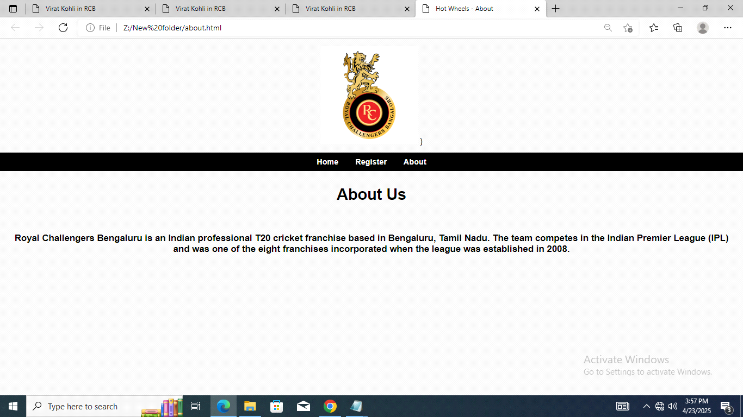

**Fig.2.5.5. About page for Royal Challengers Bengaluru.**

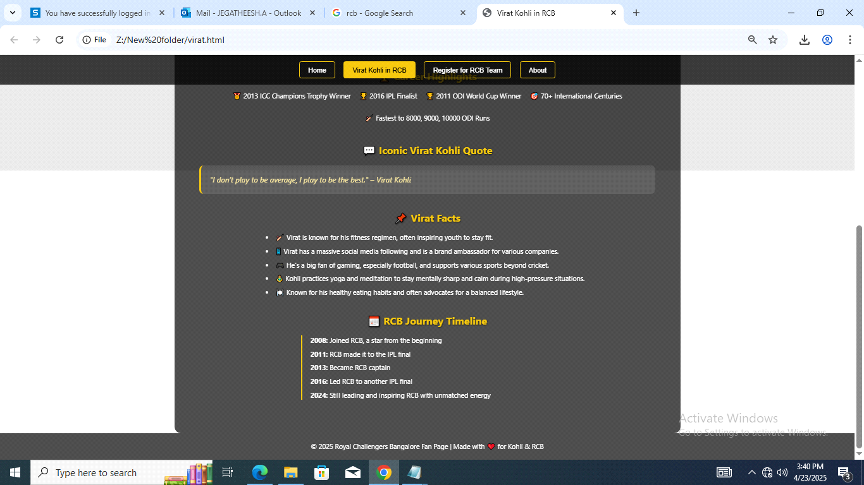

**Fig.2.4.1.6. VIRAT KOHLI** **Key Historical Moments**

**CHAPTER 3 RESULTS AND DISCUSSION**

* **RESULTS:**

The registration initiative for Royal Challengers Bangalore (RCB) garnered an overwhelmingly positive response from fans and cricket enthusiasts alike. Through the dedicated online platform, a significant number of users successfully registered, demonstrating their unwavering support and enthusiasm for the team. The streamlined registration process enabled fans to connect directly with the RCB franchise, receive regular updates, and engage in exclusive activities such as contests, merchandise launches, and fan events. This not only enhanced fan interaction but also strengthened the sense of belonging within the RCB community. The platform also provided valuable insights into fan demographics and preferences, which will help tailor future fan experiences and marketing efforts to ensure an even stronger connection between RCB and its supporters.

* **DISCUSSION:**

The registration process for Royal Challengers Bangalore (RCB) proved to be an effective tool for fostering stronger connections between the franchise and its diverse fan base. The initiative successfully attracted a large volume of registrations, showcasing the deep passion RCB fans have for the team. However, it also revealed areas that could be improved, particularly in terms of user experience and accessibility. Some users faced challenges during the registration process, especially with mobile device compatibility and the ease of navigating the platform. Addressing these issues would ensure a smoother experience for a wider demographic of fans.Moreover, the data gathered through this registration initiative presents an opportunity to gain valuable insights into fan preferences and behaviors, which can help RCB refine future marketing strategies and fan engagement activities. Moving forward, introducing interactive features such as personalized fan experiences, offering rewards for registration, and enabling social media integration for easy sharing could enhance the registration process. These improvements would create an even more immersive and engaging experience for RCB fans, ultimately strengthening their loyalty and connection to the franchise.

.

**CHAPTER 4 CONCLUSION**

In conclusion, the Royal Challengers Bangalore (RCB) registration initiative has successfully strengthened the bond between the franchise and its passionate fan base. The process not only allowed RCB to create a comprehensive fan database but also provided valuable insights into fan preferences, which can help enhance future fan engagement strategies. Despite some challenges in user experience, the overall success of the initiative highlights the immense potential of digital engagement in sports. With continuous improvements to the platform and the integration of personalized features, this registration system can evolve into a vital tool for expanding RCB’s fan base and ensuring long-term loyalty. This initiative has laid a strong foundation for cultivating deeper fan relationships, which will further solidify Royal Challengers Bangalore as one of the most iconic and celebrated franchises in the IPL.REFERENCES:

<https://manojkumxr-web.github.io/web/>

<https://www.royalchellengersbengaluru.com/signup>